Chapter 2
How to use the Management Studio

Before you do the exercises for this chapter
If you’re working on your own PC, you’ll need to set up your system as described in Appendixes A and B before you can do these exercises. In particular, you’ll need to install SQL Server Express, the Management Studio Express, and Books Online as described in Appendix A. In addition, you’ll need to download and install the files that come with this book as described in Appendix B.

Exercises
1. Use the Management Studio to view all of the databases that are available from the server. If the AP database isn’t available, attach it to the server. Then, view the tables that are available from the AP database. Finally, view the columns that are available from the Invoices tables. Note the primary and foreign keys of this table and the definition for each column.
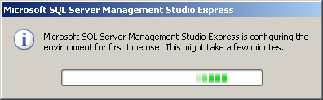
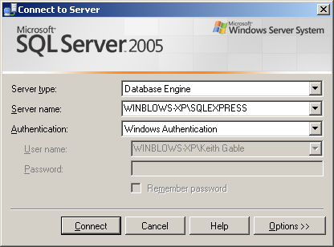
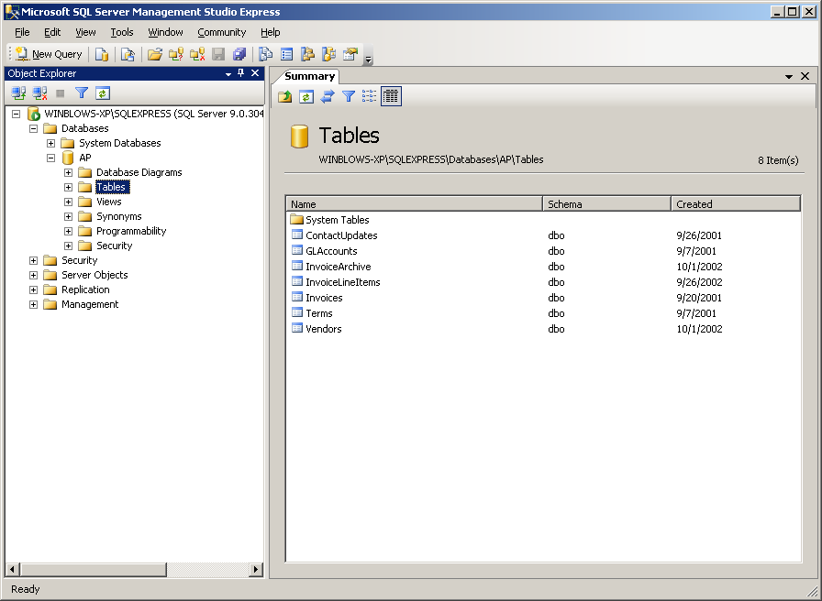
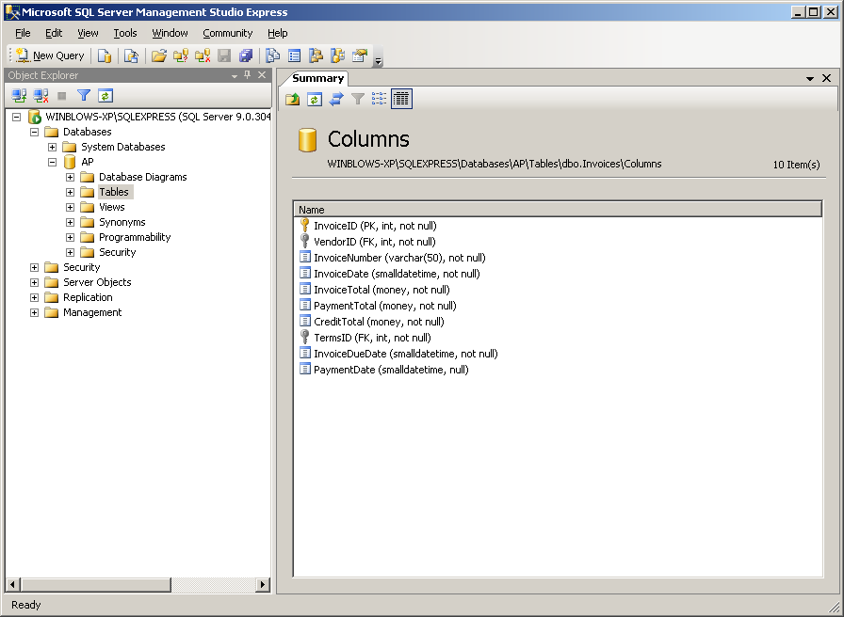

2. Right-click on the Vendors table and select the Modify command to display the Vendors table in a Table tab. Review the properties for each column in this table. In particular, note that the VendorID column is defined as an identity column.
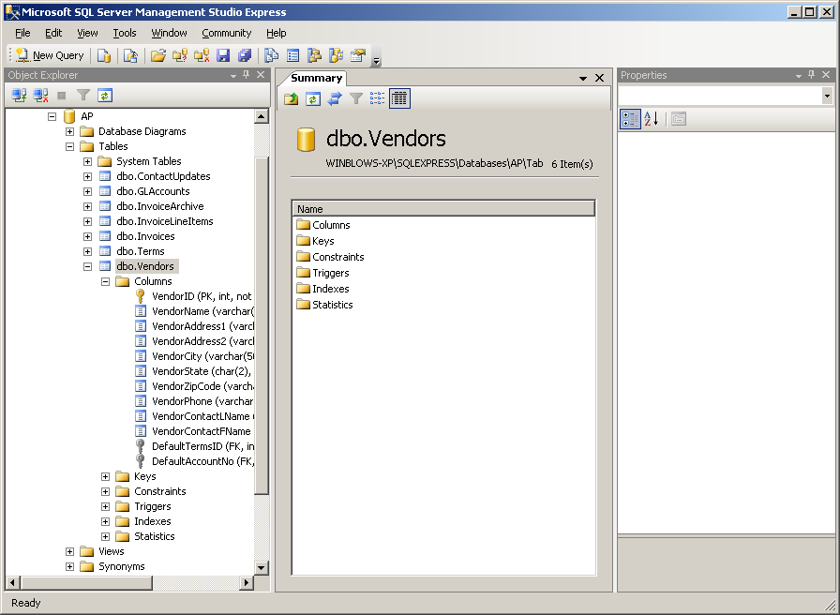
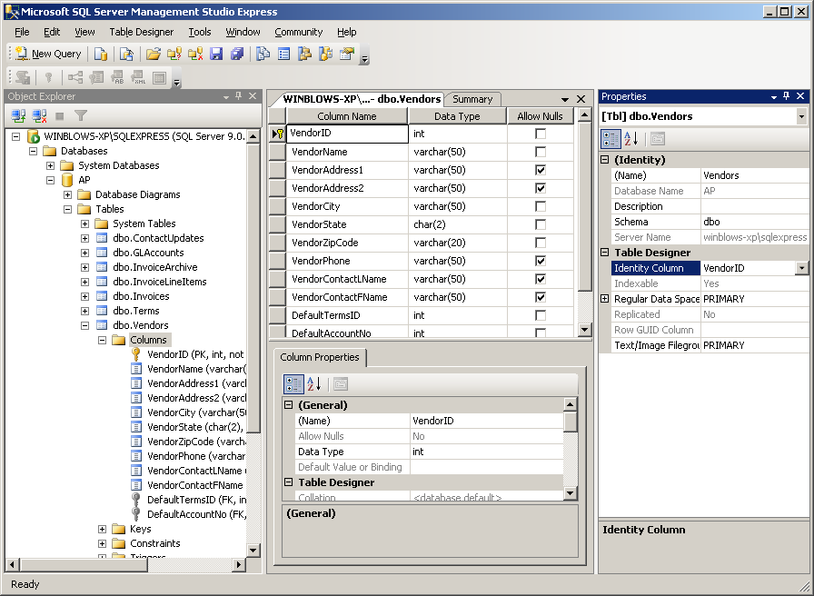
3. Use the Management Studio to create a diagram for the AP database. Then, organize the tables and connecting lines in the diagram so they are easy to read. (Hint: You can use the Autosize Selected Tables button and the Arrange Tables button in the toolbar to help you do this.) Finally, review the information that’s contained in each table, note the primary key of each table, and try to identify the relationships between the tables.
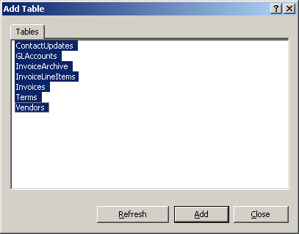
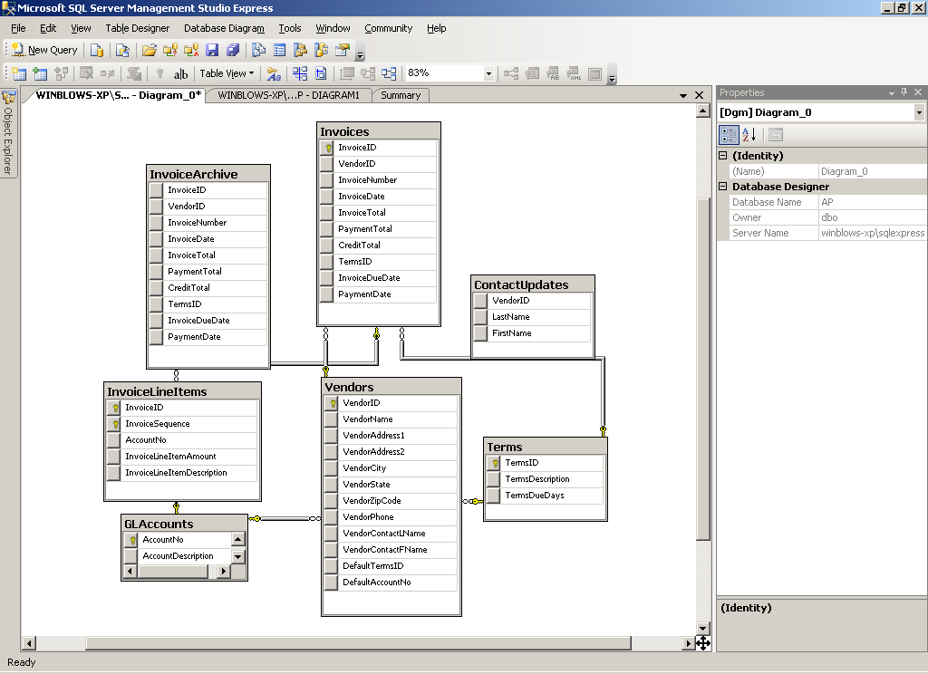
4. Start a new query and use the Query Editor to enter
SELECT VendorName, VendorState
FROM Vendors
WHERE VendorState = 'CA'
Press F5 to execute the query and display the results. If an error is displayed, correct the problem before you continue. (Hint: If you get an error message that indicates that ‘Vendors’ isn’t a valid object, the AP database isn’t the current database. To fix this error, select the AP database from the Available Databases combo box in the SQL Editor toolbar.) Then, save the query with a name of VendorsInCA and close it.
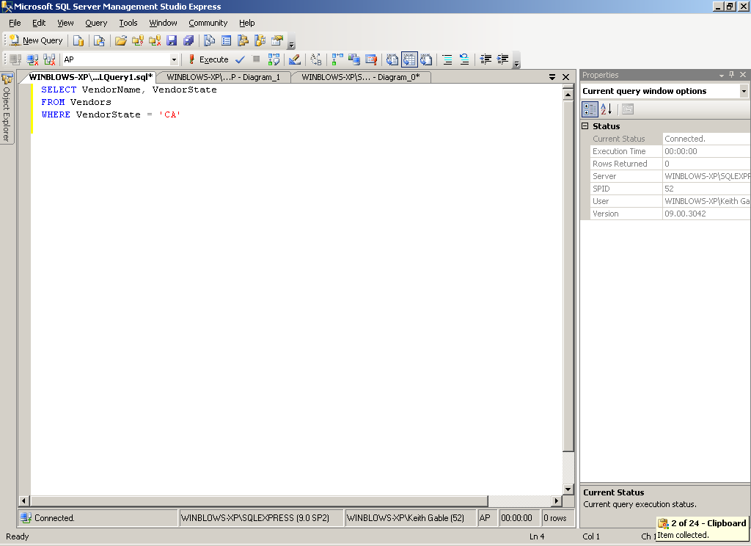
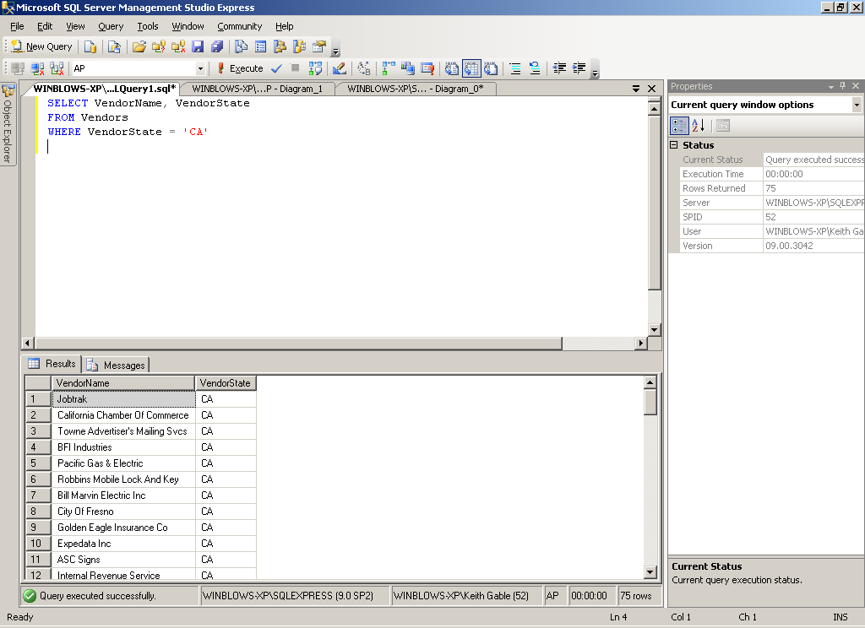
5. Open the query named VendorsInCA that you saved in exercise 4. Then, click the Execute Query toolbar button to execute it. (Hint: You may need to select the AP database from the Available Databases combo box.)
6. Use Books Online to look up information about the Query Editor. The easiest way to do this is to use the Index tab to look up “query editor”. Then, click on some links and navigate to some related topics and use the Back button to return to the original topic. Continue experimenting with the various features of Books Online until you feel comfortable with this tool. If you’re using SQL Server Express, you may want to limit the amount of information that’s displayed by selecting SQL Server Express from the Filter By combo box.
